10/8/2022

PF lab Assignment

Lab#06

Abdullah Shafiq

22k-4489

**Task 01**

Find out the given number is even or not using Ternary Operator in C.

PROGRAM & OUTPUT:

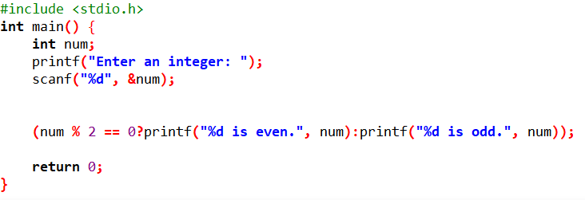



**Task 02**

Write a program to find the greatest number among three numbers using nested if else.

PROGRAM & OUTPUT:

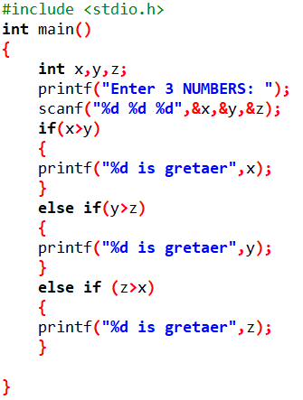

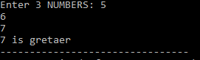

**Task 03**

Rewrite the following program segment using the if-else statements instead of the ternary operator.

String grade = (mark >= 90) ? “A” : (mark >= 80) ? “B” : “C”;

PROGRAM & OUTPUT:

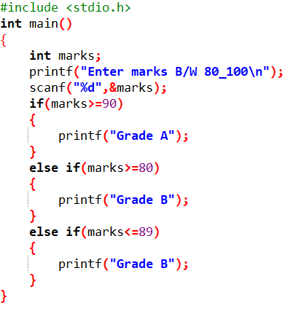

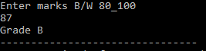

**Task 04**

A restaurant named Sandwiches Town makes sandwiches. You order a sandwich and you're asked what kind

of sandwich you would like: chicken, beef or vegetarian. You select vegetarian and you're asked to select

from a choice of three vegetarian combinations:

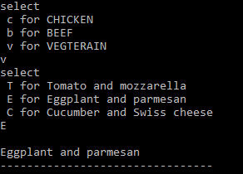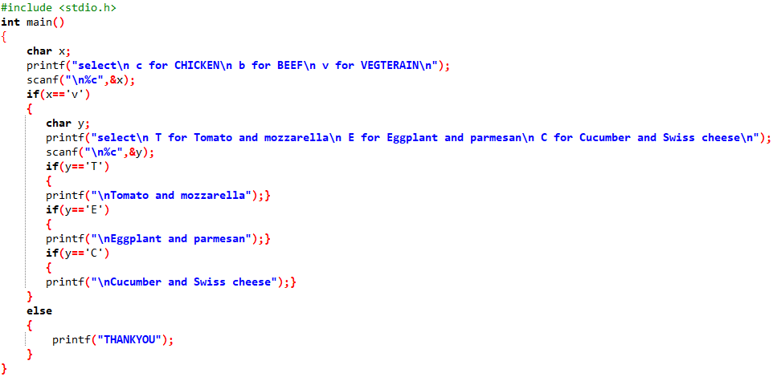PROGRAM & OUTPUT:

**Task 05**

A leap year is a year that has 366 days, instead of 365 days. It has one day extra in the month of February.

Leap years occur once in 4 years, so any year that is completely divisible by four should be a leap year. But

this is not always true. If there is some year and it is divisible by hundred, it will be a leap year only if it is

also divisible by four hundred. Given a year, check if it a leap year or not using nested if else statement.

PROGRAM & OUTPUT:

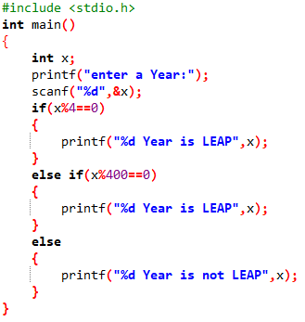



**Task 06**

Check whether the triangle is equilateral, scalene, or isosceles.

PROGRAM & OUTPUT:

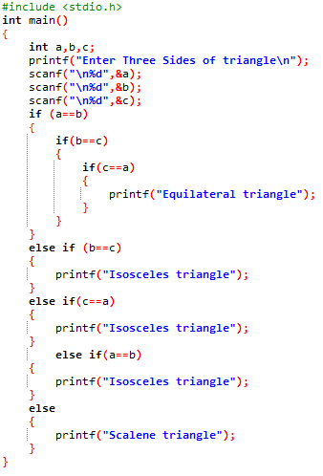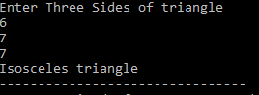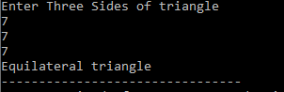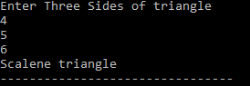

**Task 07**

Write a program to control a coffee machine. Allow the user to input the type of coffee as B for Black and W for White Ask the user if the cup size is double and if the coffee is manual. The following table details the time chart for the machine for each coffee type. Display a statement for each step. If the coffee size is double, increase the baking time by 50 percent. Use functions to display instructions to the user and to compute the coffee time.

PROGRAM & OUTPUT:

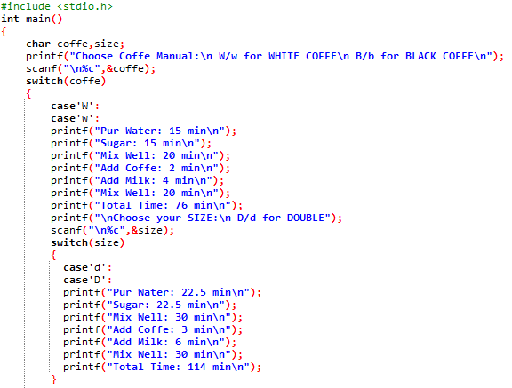

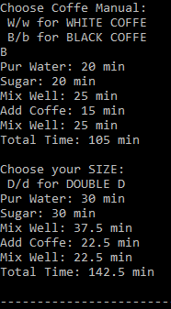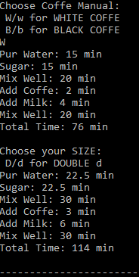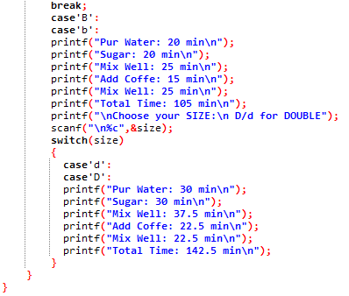

**Task 08**

You are searching for a department in a university and you’re asked to select a school from a choice of three

schools namely:

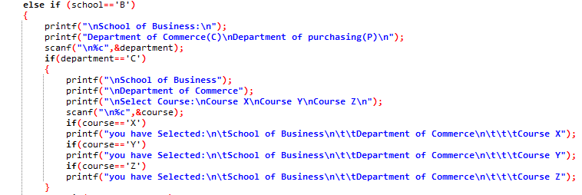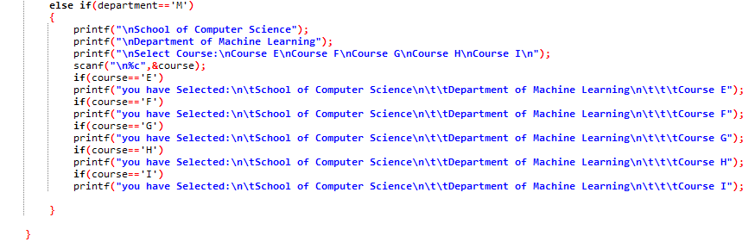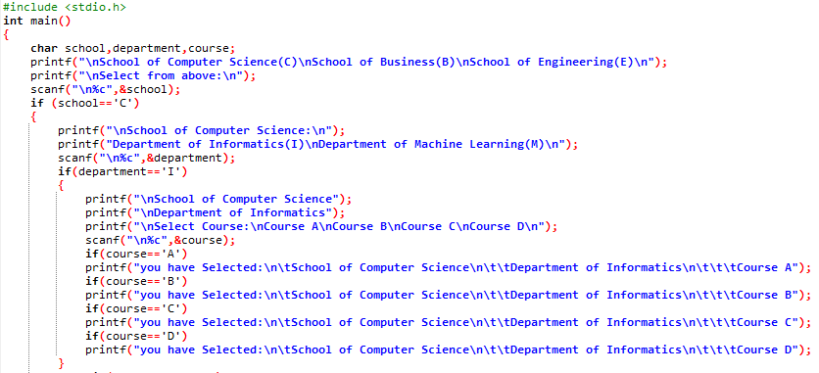PROGRAM & OUTPUT:

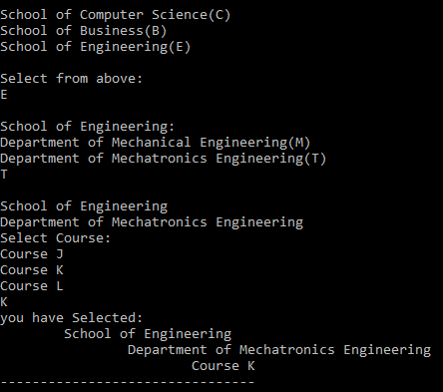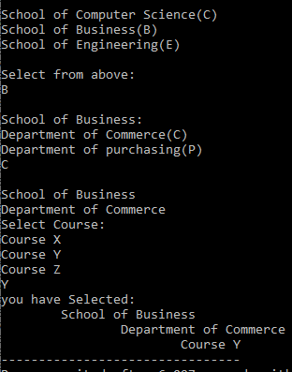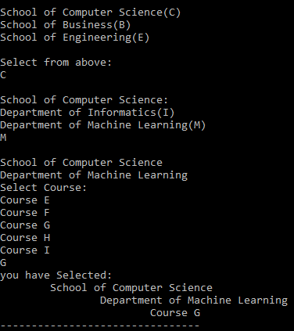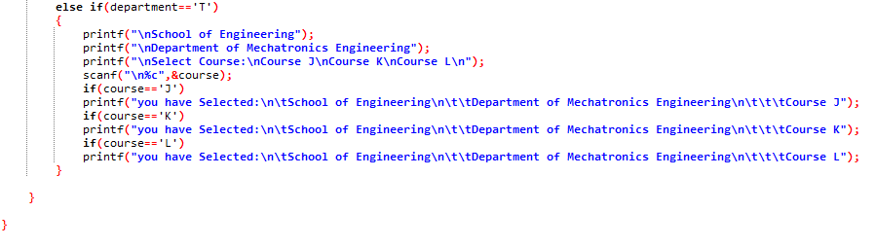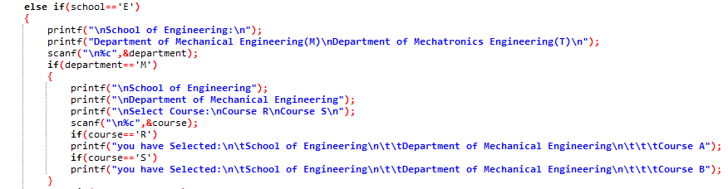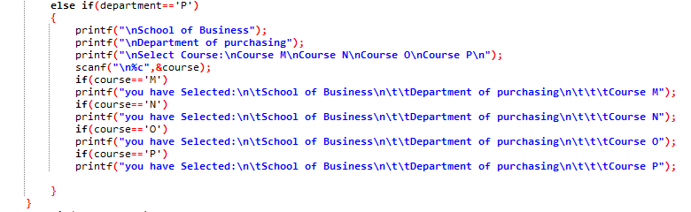

**Task 09**

Mortgage Calculator) Develop a C program to calculate the interest accrued on a bank customers mortgage.

For each customer, the following facts are available:

a) the account number

b) the mortgage amount

c) the mortgage term

d) the interest rate

The program should input each fact, calculate the total interest payable (= mortgage amount × interest rate ×

mortgage term), and add it to the mortgage amount to get the total amount payable. It should calculate the

required monthly payment by dividing the total amount payable by the number of months in the mortgage

term. The program should display the required monthly payment rounded off to the nearest dollar. The

program should process each customer’s account at a time.

PROGRAM & OUTPUT:

